Note: Include this page only when adding / amending / deleting a document. If using this document as a record, this Revision History page can be omitted.

REVISION HISTORY

Revision no | Date | Description of Changes | Reason for Revision | Revised by | Approvedby
1 | 19 Apr 13 | - Add revision history page | - Recommendation from Stage 2 audit | RDPlacido
2 | 11 Dec 15 | - Added Disclaimer  - Changed month when the survey is administered. | - Printing is sole responsibility of the person who printed it  - To get results before the following year’s planning | RCGanal | ECVentura

- Objective

To get the employees' opinion if the company is able to obtain its vision of “a happy place to work with”

To isolate root cause of persistent problems such as low productivity, absenteeism, poor performance, etc.

To allow employees an opportunity to offer inputs and the management team an opportunity to review and refine company policies and rules.

- Scope

This procedure defines the contents of the employee survey which will be used to help improve how things are run within the company.

- Definition of Terms

None

- Procedure Details

RESPONSIBLE | ACTIVITY | INTERFACE
HR  Management Committee | 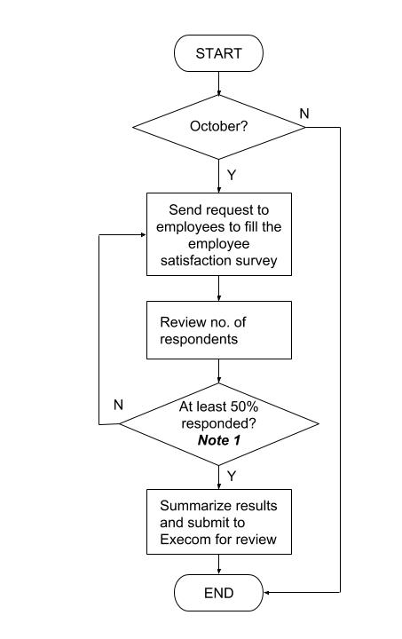 | Employee Satisfaction Survey  Summary of the Employee Satisfaction Survey  Minutes of the Meeting on the Results of the survey

Notes:

1. At least 50% of regular employees should answer the survey.

- References
- Employee Satisfaction Survey
- Summary of the Employee Satisfaction Survey
- Minutes of the Review of the Employee Survey Results

- Quality Records
- Employee Satisfaction Survey
- Employee Satisfaction Survey Report

